Shashank Thakare

Assignment 8 July 2019

Q1. what is stakeholder?

A. Stakeholder are people in company those are interest in company comes through a direct relationship like employe, investor, supplier, and other.

Q2. Challenges face while software engineering implement ion?

A.

* Complex requirement
* Undefined system boundaries
* Client not clear about needs
* Changing requirements
* Partitioning the system
* Validating and tracing requirement
* Identifying critical requirements

Q3. Different between Service and product base company

A. Both business are working in same manner as exchange of service or product with customer. The difference between them is one sell physical and other sell is skill of service. The service based company are lawyer, plumber, Taxi and other which offers service of their skill to customer. These company are strongly depend of customer service and relationship management. The relationship management labour cost is highest expenditure.

Product base company are which sell physical thing to customer like Apple, ford, general electronics and other. These company deliver physical product that are reasonably consistent in quantity for each customer. The manufacturing cost is biggest expenditure and customer availability is can be worldwide. As the physical product can be deliver all around the world.

Q4. What is V model in SDLC

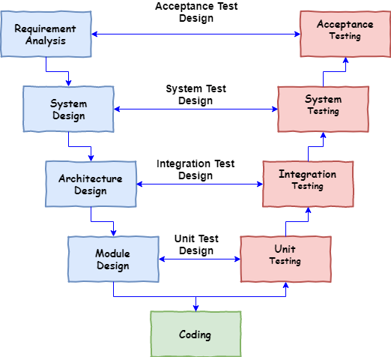A. It is one of the methodologies in SDLC where project development is in linear manner, where validation stage for each related development phase.